**ML EXPERIMENT 4**

# Import libraries

import pandas as pd

import numpy as np

import matplotlib.pyplot as plt

import seaborn as sns

from sklearn.model_selection import train_test_split

from pandas.core.common import random_state

from sklearn.linear_model import LinearRegression

# Get dataset

df_sal = pd.read_csv('/content/Salary_Data.csv')

df_sal.head()

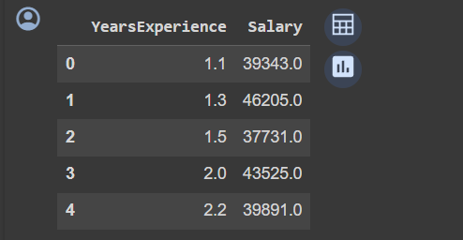

# Describe data

df_sal.describe()

# Data distribution

plt.title('Salary Distribution Plot')

sns.distplot(df_sal['Salary'])

plt.show()

# Relationship between Salary and Experience

plt.scatter(df_sal['YearsExperience'], df_sal['Salary'], color = 'lightcoral')

plt.title('Salary vs Experience')

plt.xlabel('Years of Experience')

plt.ylabel('Salary')

plt.box(False)

plt.show()

# Splitting variables

X = df_sal.iloc[:, :1]  # independent

y = df_sal.iloc[:, 1:]  # dependent

# Splitting dataset into test/train

X_train, X_test, y_train, y_test = train_test_split(X, y, test_size = 0.2, random_state = 0)

# Regressor model

regressor = LinearRegression()

regressor.fit(X_train, y_train)

# Prediction result

y_pred_test = regressor.predict(X_test)     # predicted value of y_test

y_pred_train = regressor.predict(X_train)   # predicted value of y_train

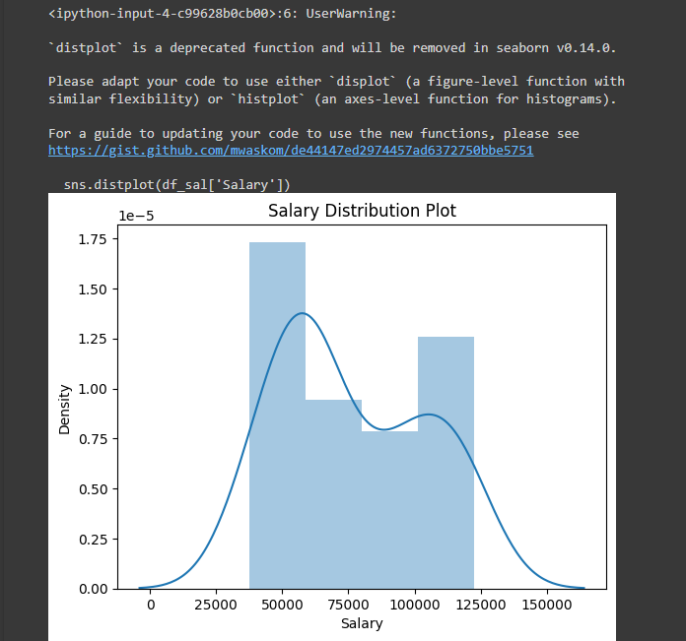 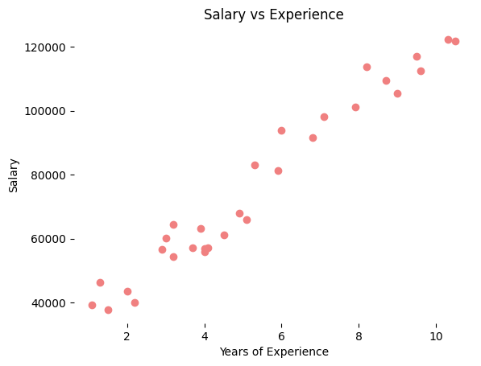

# Prediction on training set

plt.scatter(X_train, y_train, color = 'lightcoral')

plt.plot(X_train, y_pred_train, color = 'firebrick')

plt.title('Salary vs Experience (Training Set)')

plt.xlabel('Years of Experience')

plt.ylabel('Salary')

plt.legend(['X_train/Pred(y_test)', 'X_train/y_train'], title = 'Sal/Exp', loc='best', facecolor='white')

plt.box(False)

plt.show()

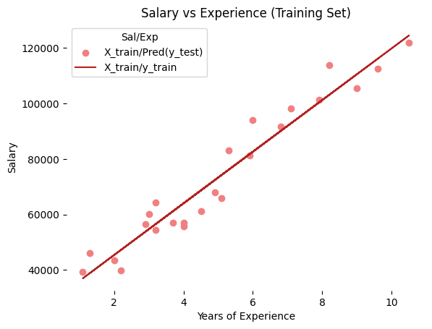

# Prediction on test set

plt.scatter(X_test, y_test, color = 'lightcoral')

plt.plot(X_train, y_pred_train, color = 'firebrick')

plt.title('Salary vs Experience (Test Set)')

plt.xlabel('Years of Experience')

plt.ylabel('Salary')

plt.legend(['X_train/Pred(y_test)', 'X_train/y_train'], title = 'Sal/Exp', loc='best', facecolor='white')

plt.box(False)

plt.show()

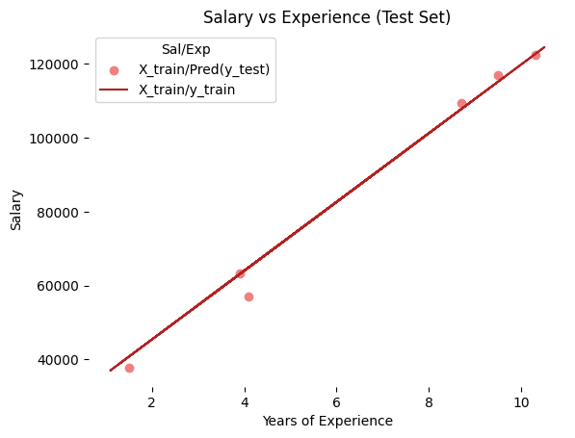

# Regressor coefficients and intercept

print(f'Coefficient: {regressor.coef_}')

print(f'Intercept: {regressor.intercept_}')

